1.HIVE USECASE

a) Create a Hive Table including Complex Data Types

b) Use built-in functions in your queries

c)Perform 10 intuitive questions in Dataset (e.g.: pattern recognition, topic discussion, most important terms, etc.). Use your innovation to think out of box.

Data used – Zomato data - 9551 rows

Created a hive table and loaded Zomato data into the table

Basic query to check if all the data is loaded

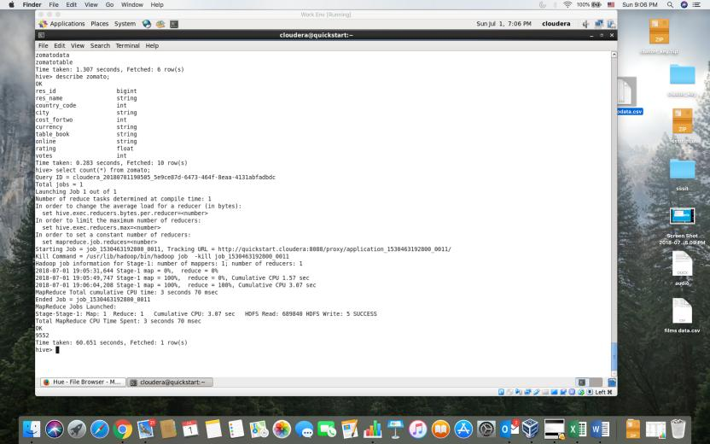

Query returns restaurant name and cost order by rating

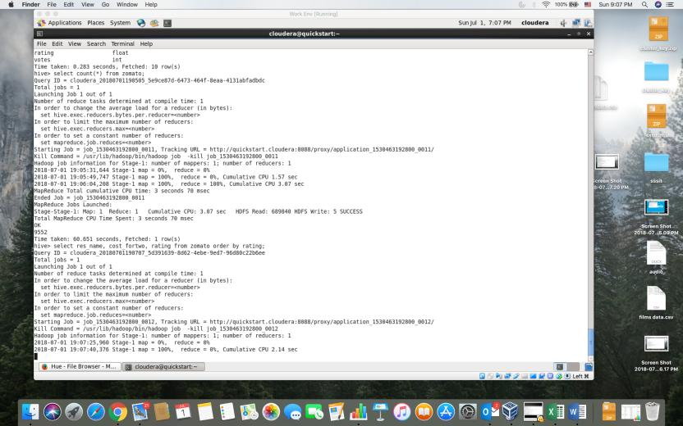

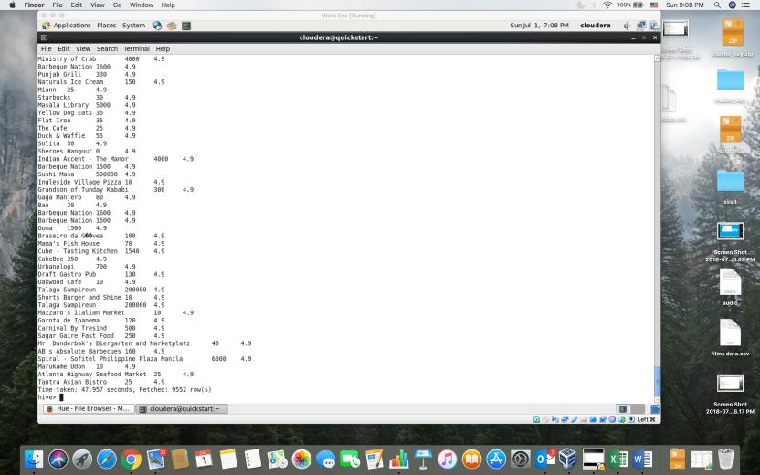

Count number of restaurants in each city

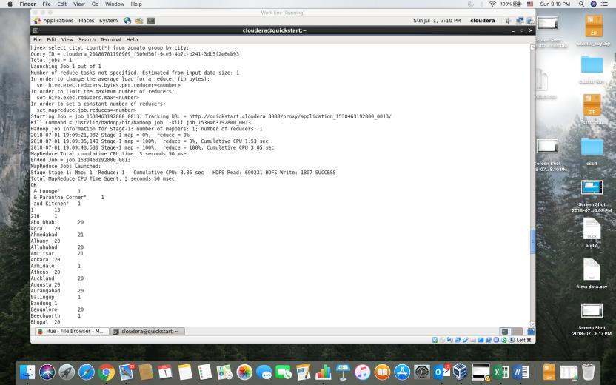

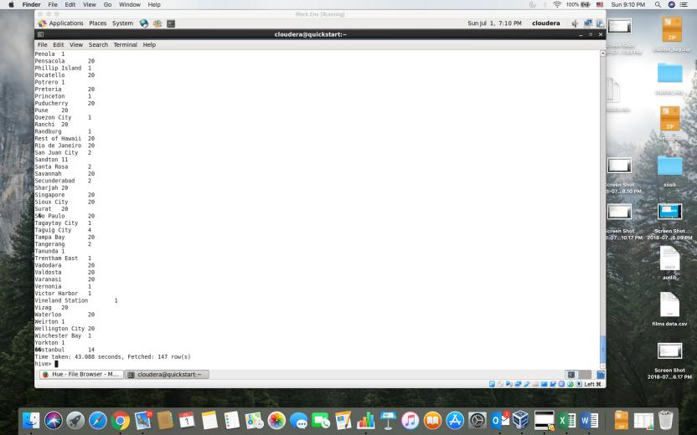

Query returns the max rating from the restaurants list which is 4.9

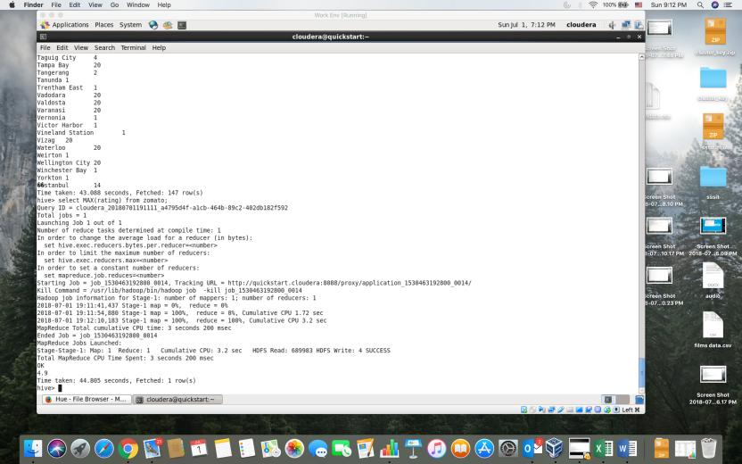

Query return the minimum cost for two people from the Zomato data – as the cost field is empty in some fields it returned 0.

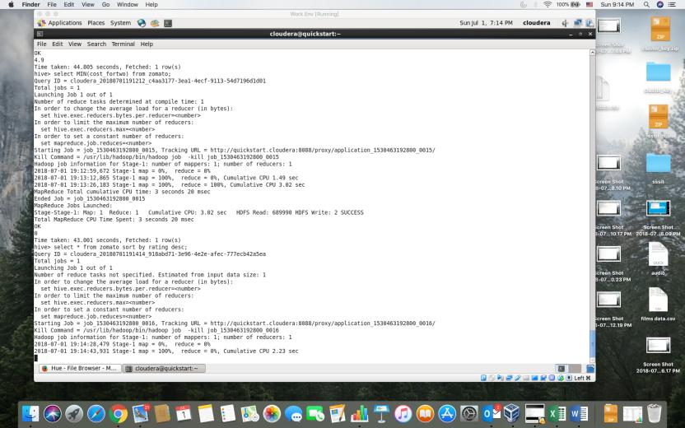

Query returns all the rows from Zomato data sorting them according to rating.



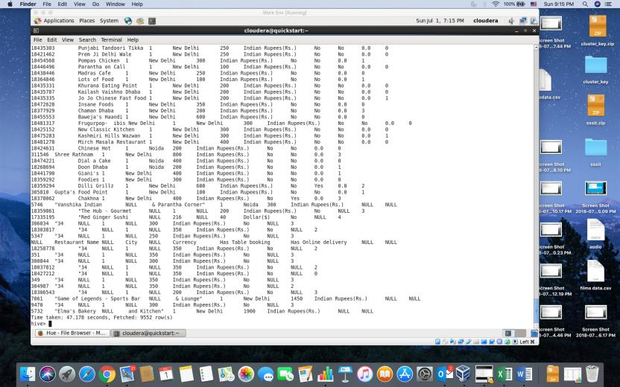

Query returns number of countries that are included in Zomato data – 15 different countries

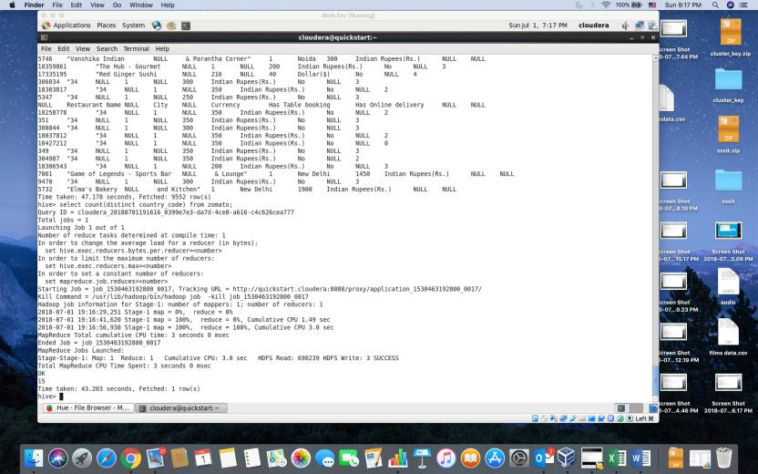

Query returns average cost to dine in restaurants whose rating is greater than 4. Since some cost values are zero average is not accurate.

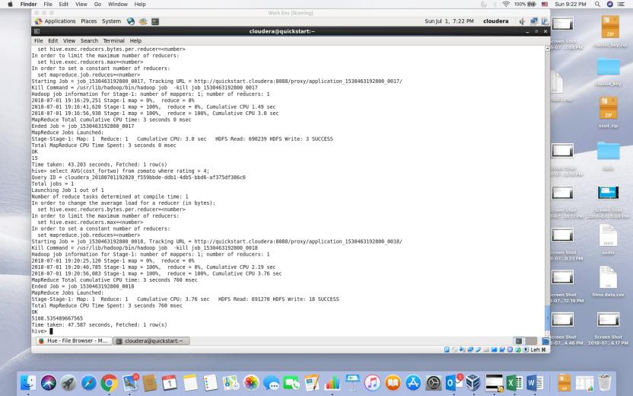

Query returns the restaurants from GOA whose rating is greater than 4.5

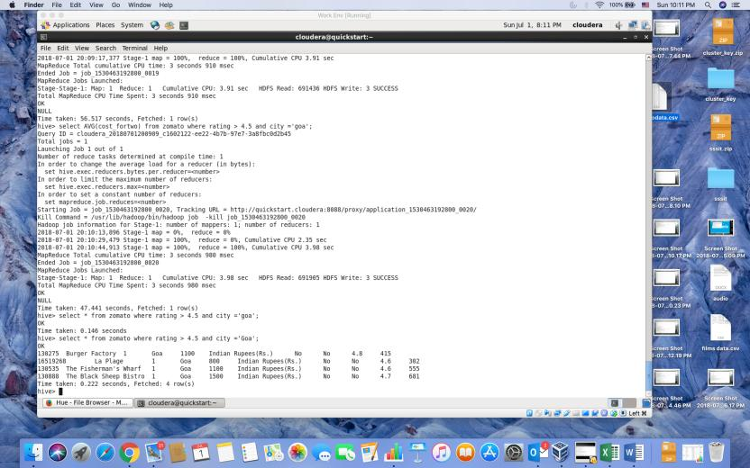

Query returns restaurants from dubai whose rating is greater than 4 and order by rating

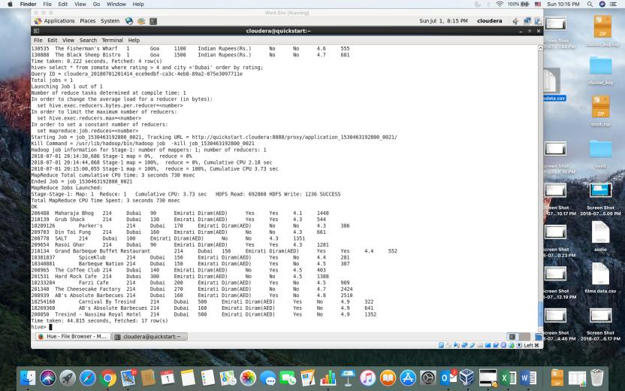

Query returns budget restaurants with good rating and less cost

